Design Phase Report

Category: Application Development
Title: KEA – Engineering Seats Allotment

List of Team Members:
USN | ROLL NO | NAME
01FE20BCS095 | 230 | Mayuri Kalmat
01FE20BCS096 | 231 | Parag Hegde
01FE20BCS099 | 234 | Pranav Jadhav
01FE20BCS098 | 233 | Yashvardhan Diwan

Team Leader: Yashvardhan Diwan

Responsibilities:
Mayuri Kalmat | ER diagram 1, Problem Statement, Documentation
Parag Hegde | ER diagram 3, Relational schema
Pranav Jadhav | ER diagram 2, Data dictionary
Yashvardhan Diwan | Normalization, Table creation

All four members have done the finalized ER diagram.

Problem Description: We have chosen KCET counselling as the real-world problem. In Karnataka, KEA is the authority that manages the counselling and admission of students to the professional courses after their class XII. During these Covid times, it is nearly impossible for the students to take part in the offline counselling. So, to overcome this problem, we have designed an online KEA counselling database in the favor of students, using SQL.

Requirements Specification: There are no any specific changes in our previous and current Entity Relationship (ER) diagrams.
Design Questions to be answered
Question 1: From the problem description, identify the entities that need to be represented in the database, the attributes of each entity, the relationships between the entities, and the cardinality ratios of each relationship.
STUDENT: App_no, S_Ph_no, S_state, Address, S_name, Age, Gender, email
STUDENT_CREDENTIALS: CET_No, Rank, Quota, Password
COLLEGE: C_id, C_Name, C_City, C_Ph_No
BRANCH: B_id, B_Name, Category _Seats
CHOICE: User_id, Ch1, Ch2, Ch3, Ch4
GUARDIAN: G_Name, Income, G_Ph_No, G_Aadhar_No, G_State, Mtr_Tongue
ADMITTED: Fees, App_No, C_id,
Relationships with cardinality ratio (Relationship underlined)
- Student owns Student credentials. (1:1)
- Student allotted to college. (M: N)
- College consists of branch. (1: N)
- Student has Guardian. (1: N)
- Student enters Choices. (1: N)

Question 2: Draw an Entity-Relationship Diagram illustrating the information you have identified in Question 1.

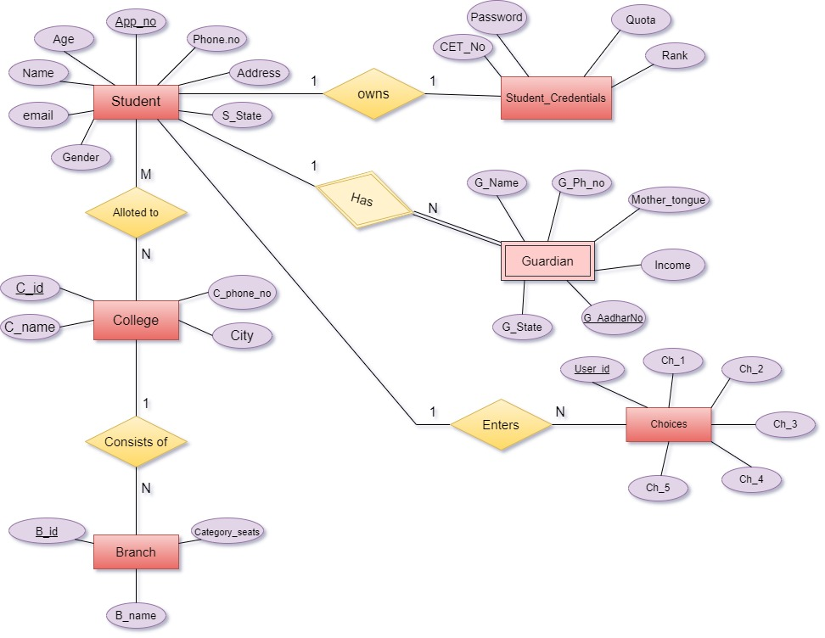
ER Diagram 1

Question 3: Draw alternate Entity-Relationship Diagram illustrating the information you have identified in Question 1 that you think are most likely to occur.
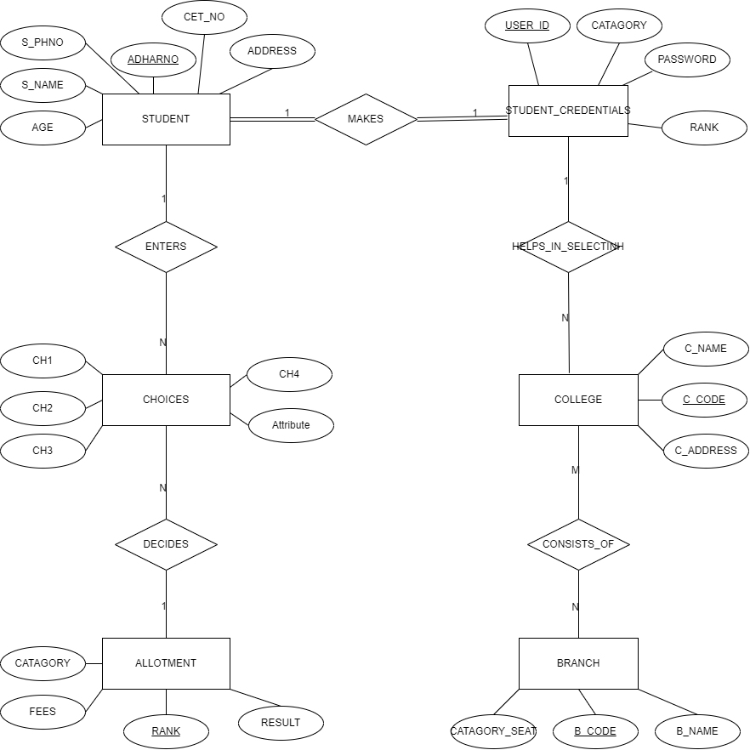
ER diagram 2
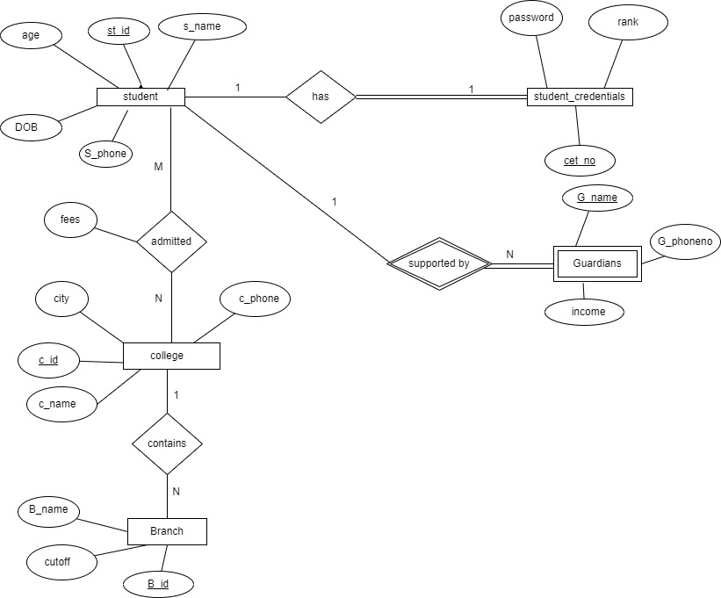

ER diagram 3

Question 4: Choose the optimal Entity-Relationship Diagram from the designs provided above and justify why you think this is an optimal solution for your identified problem specification.
ANSWER FOR CHOICE AND JUSTIFICATION
OPTIMAL ER DIAGRAM

JUSTIFICATION-: Clear mention of all cardinality ratios, use of appropriate entities , proper participation types, clear description of the relationship.
[Optional] Question 5: Draw an Object Model illustrating the information you have identified in Question 2.
DRAW YOUR OBJECT MODEL DIAGRAM HERE

Question 6: Draw an ER to Relation Mapping illustrating the information you have identified in Question 4.
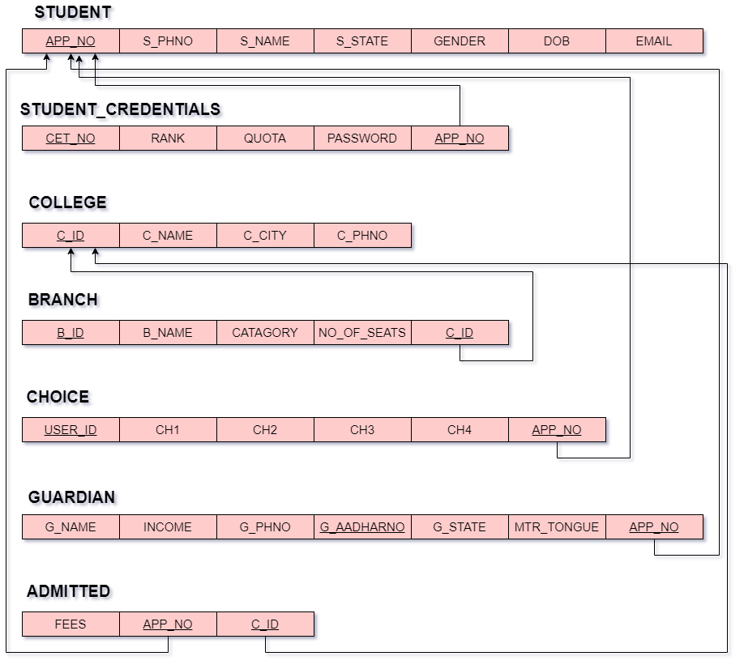
ER TO RELATIONAL MAPPING DIAGRAM

Question 7: Draw a Data Dictionary illustrating the information you have identified in Question 6.
Object  (Entity) | Name  (Attribute) | Type | Description | Primary Key | Foreign Key
STUDENT | App_No | Varchar | Student’s  CET Application number | YES | NO
STUDENT | S_Name | Varchar | Name of student | NO | NO
STUDENT | S_Phno | Integer | Student’s contact  number | NO | NO
STUDENT | S_State | Varchar | State name where the student resides. | NO | NO
STUDENT | Gender | Varchar | States the gender of the student. | NO | NO
STUDENT | DOB | Date | Student’s date of birth. | NO | NO
STUDENT | Email | Varchar | Student’s email address. | NO | NO
STUDENT_CREDENTIALS  STUDENT_CREDENTIALS | CET_No | Varchar | Student’s CET Hall-ticket number. | YES | NO
STUDENT_CREDENTIALS  STUDENT_CREDENTIALS | Rank | Integer | Rank obtained by the student in the CET exam. | NO | NO
STUDENT_CREDENTIALS  STUDENT_CREDENTIALS | Quotas | Varchar | Specifies the privileged quota such as NCC, army, rural etc, (If any) | NO | NO
STUDENT_CREDENTIALS  STUDENT_CREDENTIALS | Passwords | Varchar | Password used by the students to log into their accounts. | NO | NO
STUDENT_CREDENTIALS  STUDENT_CREDENTIALS | App_No | Varchar | Student’s  CET Application number. It references the STUDENTS table. | NO | YES
COLLEGE | C_ID | Varchar | It is a unique id assigned to each college. | YES | NO
COLLEGE | C_Name | Varchar | Official name of the college. | NO | NO
COLLEGE | C_City | Varchar | Specifies the location where the college is situated. | NO | NO
COLLEGE | C_Phno | Integer | Contact number of college office. | NO | NO
BRANCH | B_ID | Varchar | A unique id assigned to each branch. |  | NO
BRANCH | B_Name | Varchar | Branch Name. | NO | NO
BRANCH | Category | Varchar | Specifies the category to which the student’s caste belongs. | NO | NO
BRANCH | No_of_seats | Integer | Specifies the number of seats distributed according to the categories. | NO | NO
BRANCH | C_ID | Varchar | It is a unique id assigned to each college. It references COLLEGE table. |  | YES
CHOICE  CHOICE | User_ID | Varchar | Student’s user id to  log-in. | NO | NO
CHOICE  CHOICE | Ch_1 | Varchar | Choice of colleges entered by the student in the choice entry. | NO | NO
CHOICE  CHOICE | Ch_2
CHOICE  CHOICE | Ch_3
CHOICE  CHOICE | Ch_4
CHOICE  CHOICE | Ch_5
CHOICE  CHOICE | App_No | Varchar | Student’s  CET Application number. It references the STUDENTS table. | YES | YES
GUARDIAN | G_Name | Varchar | Guardian’s Name. | NO | NO
GUARDIAN | Income | Integer | Specifies the income as per the income tax certificate. | NO | NO
GUARDIAN | G_Phno | Integer | Guardian’s Contact Number. | NO | NO
GUARDIAN | G_AadhaarNo | Varchar | Guardian’s Aadhaar Number. | YES | NO
GUARDIAN | MTR_Tongue | Varchar | Specifies the student’s mother tongue. | NO | NO
GUARDIAN | G_state | Varchar | Specifies the domicile. | NO | NO
GUARDIAN | App_No | Varchar | Student’s  CET Application number. It references the STUDENTS table. | YES | YES
ADMITTED | Fees | Integer | Specifies the fees for every college. | NO | NO
ADMITTED | App_No | Varchar | Student’s  CET Application number. It references the STUDENTS table.  Denotes which student has been allocated which college | YES  (Both together) | YES
ADMITTED | C_ID | Varchar | It is a unique id assigned to each college. It references COLLEGE table. | YES  (Both together) | YES

Question 9: Normalization: Are all the relations in your chosen schema in 3NF? Are they in BCNF? Explain your answers. If any of your relations are not in BCNF, normalize them to BCNF. If you choose to normalize your relations only till 2NF or 3NF, explain your reasons (e.g., the amount of redundancy introduced is limited or some other valid reason).
1.STUDENT
(App_no, S_name, S_state, Phone_no, age, DOB, E-mail)
- The relation is in 1NF because there are no attributes that can hold more than
one values. The attributes are holding only atomic values.
- The relation is in 2NF as the primary key contains only one attribute, hence
every attribute in the relation is fully functionally dependent on the primary key.
- The given relation is in 3NF because there are no any transitive functional
dependency.
- The given relation is in BCNF there are no non-prime attributes determining
non-prime attribute.

2.STUDENT_CREDENTIAL
(Cet_no, App_no , password , rank, quota)
- The relation is in 1NF because there are no attribute having multiple values.
The attributes are holding only atomic values.
- As the primary key (set_no,app_no) can determine all other attributes and
there is no any partial dependency hence the relation is in 2NF.
- The given relation is in 3NF because there are no any transitive functional
dependency.
*The given relation is in BCNF there are no non-key attributes determining non-key attribute.
3. COLLEGE
(C_id, C_name, C_city, C_phone)
- The relation is in 1NF because there are no attribute having multiple values.
The attributes are holding only atomic values.
- As the primary key can determine all other attributes and there is no any partial
dependency hence the relation is in 2NF.
- The given relation is in 3NF because there are no any transitive functional
dependency.
- Similarly given relation is in BCNF there are no non-key attributes
determining non-key attribute.
4. BRANCH
(B_id,C_id,B_name,GEN,OBC,SC)
- The relation is in 1NF because there are no attribute having multiple values.
The attributes are holding only atomic values.
- As the primary key can determine all other attributes and there is no any partial
dependency hence the relation is in 2NF.
- The given relation is in 3NF because there are no any transitive functional
dependency.
- The given relation is in BCNF there are no non-key attributes determining
non-key attribute.
5.CHOICE
(User_id, App_no, ch_1, ch_2, ch_3, ch_4)
- The relation is in 1NF because there are no attribute having multiple values.
The attributes are holding only atomic values.
- As the primary key can determine all other attributes and there is no any partial
dependency hence the relation is in 2NF.
- The given relation is in 3NF because there are no any transitive functional
dependency.
- The given relation is in BCNF there are no non-key attributes determining
non-key attribute.
- GUARDIAN
(App_no, G_Adharno, G_state, income, G_phno, Mother_tongue)
- The relation is in 1NF because there are no attribute having multiple values.
The attributes are holding only atomic values.
- As the primary key can determine all other attributes and there is no any partial
dependency hence the relation is in 2NF.
- The given relation is in 3NF because there is no any transitive functional
dependency.
- The given relation is in BCNF there are no non-key attributes determining
non-key attribute.
7.ADMITTED
(App_no, C_id, fees)
- The relation is in 1NF because there are no attribute having multiple values.
The attributes are holding only atomic values.
- As the primary key can determine all other attributes and there is no any partial
dependency hence the relation is in 2NF.
- The given relation is in 3NF because there are no any transitive functional
dependency.
- The given relation is in BCNF there are no non-key attributes determining
non-key attribute.
References: We have made use of designing websites like:
draw.io ( https://www.draw.io/ )
Diagrams.net ( https://app.diagrams.net/ )
MS Word
SQL database

Proposal Phase Report
Category: Application Development
Title: KEA – Engineering Seats Allotment

List of Team Members:
Mayuri Kalmat | 01FE20BCS095 (230)
Parag Hegde | 01FE20BCS096 (231)
Pranav Jadhav | 01FE20BCS099 (234)
Yashvardhan Diwan | 01FE20BCS095 (233)

Team Leader: Yashvardhan Diwan

Responsibilities:
Mayuri Kalmat - ER diagram 1, Problem statement, Documentation of the project.
Parag Hegde - ER diagram 3, Relational schema, Table creation
Pranav Jadhav - ER diagram 2, Data dictionary
Yashvardhan Diwan – Normalization, Table formation.
All four members have done the finalized ER diagram.
Problem Description: We have chosen KCET counselling as the real-world problem. In Karnataka, KEA is the authority that manages the counselling and admission of students to the professional courses after their class XII. During these Covid times, it is nearly impossible for the students to take part in the offline counselling. So, to overcome this problem, we have designed an online KEA counselling database in the favor of students, using SQL.

Requirements: [list out the issues that you will be addressing]
What is the application functional specifications (i.e., what functionality will your completed system provide)? You will have to account for each one of the functionalities in your demo.

* We can get the list of students who entered in the particular branch.
* We can get the list of colleges at the particular location.
* Get the details of students below the particular rank.
* Total number of seats available for the particular catogery.
* Students who belong to the particular catogery.

Implementation Phase

STUDENT:
CREATE TABLE STUDENT
(
APP_NO VARCHAR (20),
S_NAME VARCHAR (20),
S_PHNO INT,
S_STATE VARCHAR (20),
GENDER VARCHAR (20),
DOB DATE,
EMAIL VARCHAR (20),
PRIMARY KEY(APP_NO)
);

STUDENT_CREDENTIALS:
CREATE TABLE STUDENT_CREDENTIALS
(
CET_NO VARCHAR (20),
RANKS INT,
QUOTAS VARCHAR (20),
PASSWORDS VARCHAR (20),
APP_NO VARCHAR (20),
PRIMARY KEY (CET_NO, APP_NO),
FOREIGN KEY(APP_NO) REFERENCES STUDENT
);

COLLEGE:
CREATE TABLE COLLEGE
(
C_ID VARCHAR (20),
C_NAME VARCHAR (20),
C_CITY VARCHAR (20),
C_PHNO INT,
PRIMARY KEY(C_ID)
);

BRANCH:
CREATE TABLE BRANCH
(
B_ID VARCHAR (10),
B_NAME VARCHAR (40),
GEN INT,
OBC INT,
SC INT,
C_ID VARCHAR (20),
PRIMARY KEY (B_ID, C_ID),
FOREIGN KEY(C_ID) REFERENCES COLLEGE
);

CHOICE:
CREATE TABLE CHOICE
(
USER_ID VARCHAR (20),
CH1 VARCHAR (20),
CH2 VARCHAR (20),
CH3 VARCHAR (20),
CH4 VARCHAR (20),
APP_NO VARCHAR (20),
PRIMARY KEY (USER_ID, APP_NO),
FOREIGN KEY(APP_NO) REFERENCES STUDENT
);

GUARDIAN:
CREATE TABLE GUARDIAN
(
G_NAME VARCHAR (20),
INCOME INT,
G_PHNO INT,
G_AADHARNO VARCHAR (20),
G_STATE VARCHAR (20),
MTR_TONGUE VARCHAR (20),
APP_NO VARCHAR (20),
PRIMARY KEY (G_AADHARNO, APP_NO),
FOREIGN KEY(APP_NO) REFERENCES STUDENT
);

ADMITTED:
CREATE TABLE ADMITTED
(
FEES INT,
APP_NO VARCHAR (20),
C_ID VARCHAR (20),
PRIMARY KEY (APP_NO, C_ID),
FOREIGN KEY(C_ID) REFERENCES COLLEGE,
FOREIGN KEY(APP_NO) REFERENCES STUDENT
);

Question 2: Give the actual data stored in each table of the Database:

App_no | S_name | S_Phno | S_State | Gender |  | DOB | Email
202011072001 | Parag Hegade | 9844323211 | Karnataka | male | 12-07-02 |  | parag@gmail.com
202011072002 | Pranav Jadhav | 6363528974 | Karnataka | male | 13-08-02 |  | pranav@gmail.com
202011072003 | Mayuri Kalmat | 9735627290 | Maharashtra | female | 15-04-00 |  | mayo@gmail.com
202011072004 | Yashvardhan Diwan | 9837243567 | Karnataka | male | 18-01-03 |  | yash@gmail.com
202011072005 | Srujan Akkera | 8107399821 | Andra Pradesh | male | 12-07-02 |  | srujan@gmail.com
202011072006 | Karthik M | 6363928756 | Tamil Nadu | male | 12-07-02 |  | karthik@gmail.com
202011072007 | Mayur Verma | 8971129844 | Uttar Pradesh | male | 12-07-02 |  | mayur@gmail.com
202011072008 | Rohan Gowda | 7234780012 | Karnataka | male | 12-07-02 |  | rohan@gmail.com
202011072009 | Faraz | 6971123456 | Telangana | male | 12-07-01 |  | faraz@hotmail.com
202011072010 | Cyril Joseph | 971126543 | Karnataka | male | 12-07-02 |  | cyril@gmail.com
202011072011 | Subramanya | 979926573 | Karnataka | male | 12-07-02 |  | subbu@gmail.com
202011072012 | Srishti Kadam | 9823456120 | Maharashtra | female | 12-07-2002 |  | srishti@gmail.com
202011072013 | Sushir Meti | 7378656789 | Karnataka | male | 12-07-02 |  | messi@gmail.com
202011072014 | Samhith Kumar | 6364789072 | Goa | male | 12-07-02 |  | samhith@yahoo.com
202011072015 | Sushanth Hawaldar | 8779134092 | Karnataka | male | 12-07-02 |  | sushanth@gmail.com
202011072016 | Nitish Kulkarni | 8732097621 | Karnataka | male | 12-07-02 |  | sonu@gmail.com
202011072017 | Chinmay Javalagi | 7372892786 | Karnataka | male | 12-07-02 |  | chinya@gmail.com
202011072018 | Gagandeep L | 9876340912 | Maharashtra | male | 12-07-02 |  | gdeep@gmail.com
202011072019 | Pranavi Kulkarni | 8686543490 | Karnataka | female | 12-07-02 |  | pnv@gmail.com
202011072020 | Shreya Sosle | 8972365743 | Karnataka | female | 12-07-02 |  | shry@gmail.com

CET_no | Rank | Quota | Passwords | App_no
PH111 | 2235 | Rural | 1111 | 202011072001
PJ111 | 2256 |  | 2222 | 202011072002
MK111 | 3652 |  | 1212 | 202011072003
YD111 | 1145 | CRPF | 3333 | 202011072004
SA111 | 2285 |  | 1010 | 202011072005
KM111 | 8235 | Rural | 0101 | 202011072006
MV111 | 3275 |  | 0000 | 202011072007
RG111 | 8235 | Rural | 8888 | 202011072008
FM111 | 4235 | Rural | 1978 | 202011072009
CJ111 | 9235 | Kannada Medium | 1221 | 202011072010
SB111 | 2035 | Sports | 1811 | 202011072011
SK111 | 235 | Rural | 1171 | 202011072012
SM111 | 2350 | Rural | 2112 | 202011072013
SR111 | 2235 | Kannada Medium | 1631 | 202011072014
SH111 | 2935 | SNQ | 1189 | 202011072015
NK111 | 6237 | Rural | 9211 | 202011072016
CV111 | 2635 | Kannada Medium | 1561 | 202011072017
GL111 | 7235 | Rural | 1125 | 202011072018
PK111 | 8225 | SNQ | 1331 | 202011072019
SS111 | 10235 | Sports | 1881 | 202011072020

C_id | C_name | C_city | C_phno
U001 | KLE TECH | HUBBALLI | 836515173
U002 | PES UNIVERSITY | BENGALURU | 802349871
U003 | DAYANANDSAGAR | BENGALURU | 807338902
U004 | MS RAMAIAH IT | BENGALURU | 805643420
U005 | JSS CET | MYSURU | 821568944
U006 | SDMCET | DHARWAD | 836615788
U007 | BAPUJI CET | DAVANGERE | 819223234
U008 | GMIT CET | DAVANGERE | 819223234
U009 | BMS CET | BENGALURU | 803457891
U010 | BITCET | BENGALURU | 806543120

B_id | B_name | Gen | Obc | Sc | C_id
KLECSE | COMPUTER SCIENCE | 90 | 80 | 30 | U001
KLEECE | ELECTRONIC AND COMMUNICATION | 20 | 140 | 30 | U001
KLEMECH | MECHANICAL ENGINEERING | 50 | 46 | 40 | U001
PESCSE | COMPUTER SCIENCE | 68 | 72 | 30 | U002
PESECE | ELECTRONIC AND COMMUNICATION | 72 | 40 | 50 | U002
PESMECH | MECHANICAL ENGINEERING | 34 | 46 | 44 | U002
DSCSE | COMPUTER SCIENCE | 54 | 64 | 45 | U003
DSCE | ELECTRONIC AND COMMUNICATION | 34 | 45 | 23 | U003
DSECH | MECHANICAL ENGINEERING | 54 | 45 | 37 | U003
MSRCSE | COMPUTER SCIENCE | 43 | 54 | 34 | U004
MSRECE | ELECTRONIC AND COMMUNICATION | 87 | 76 | 45 | U004
MSRMECH | MECHANICAL ENGINEERING | 76 | 56 | 41 | U004
JSSCSE | COMPUTER SCIENCE | 80 | 43 | 21 | U005
JSSECE | ELECTRONIC AND COMMUNICATION | 74 | 54 | 41 | U005
JSSMECH | MECHANICAL ENGINEERING | 34 | 53 | 23 | U005
SDCSE | COMPUTER SCIENCE | 90 | 80 | 30 | U006
SDECE | ELECTRONICS AND COMMUNICATION | 80 | 70 | 60 | U006
SDISE | INFORMATION SCIENCE | 100 | 80 | 30 | U006
BPCSE | COMPUTER SCIENCE | 120 | 100 | 90 | U007
BPECE | ELECTRONICS AND COMMUNICATION | 60 | 50 | 30 | U007
BPISE | INFORMATION SCIENCE | 85 | 75 | 32 | U007
GMCSE | COMPUTER SCIENCE | 70 | 60 | 40 | U008
GMECE | ELECTRONICS AND COMMUNICATION | 75 | 65 | 31 | U008
GMISE | INFORMATION SCIENCE | 78 | 67 | 56 | U008
BMCSE | COMPUTER SCIENCE | 101 | 90 | 89 | U009
BMECE | ELECTRONICS AND COMMUNICATION | 110 | 74 | 63 | U009
BMISE | INFORMATION SCIENCE | 115 | 75 | 40 | U009
BITCSE | COMPUTER SCIENCE | 120 | 100 | 80 | U010
BITECE | ELECTRONICS AND COMMUNICATION | 118 | 103 | 20 | U010
BITISE | INFORMATION SCIENCE | 122 | 101 | 70 | U010

User_id | Ch_1 | Ch_2 | Ch_3 | Ch_4 | App_no
01FE2266 | KLETECH | BMSCET | SDMCET | JSSCET | 202011072001
01FR2587 | JSSCET | SDMCET | BMSCET | KLETECH | 202011072002
01RT2230 | DAYANANDSAGAR | KLETECH | KLETECH | SDMCET | 202011072003
20FG0265 | JSSCET | BITCET | RVCJ | NULL | 202011072004
056FFD61 | PES UNIVERSITY | BMSCET | DAYANAND SAGAR | MSRAMAIAHIT | 202011072005
DF666898 | BAPUJICET | DAYANAND SAGAR | GMITCET | BITCET | 202011072006
568FDF88 | KLETECH | MSRAMAIAHIT | SDMCET | BMSCET | 202011072007
235DDF81 | GMITCET | BAPUJICET | SDMCET | JSSCET | 202011072008
25DFG865 | BITCET | BMSCET | NULL | NULL | 202011072009
6FDD8868 | PES UNIVERSITY | BMSCET | KLETECH | NULL | 202011072010
D58868D0 | MSRAMAIAHIT | JSSCET | KLETECH | PES UNIVERSITY | 202011072011
28889GTY | BMSCET | BITCET | MSRAMAIAHIT | KLETECH | 202011072012
AD43X221 | JSSCET | SDMCET | BMSCET | KLETECH | 202011072013
98BZ0912 | BMSCET | BITCET | JSSCET | JSSCET | 202011072014
LO5421KG | KLETECH | PES UNIVERSITY | DAYANAND SAGAR | MSRAMAIAHIT | 202011072015
QO0234KL | JSSCET | SDMCET | BAPUJICET | GMITCET | 202011072016
92AG82RT | BITCET | BMSCET | GMITCET | BAPUJICET | 202011072017
PB34GH09 | KLETECH | BMSCET | SDMCET | JSSCET | 202011072018
LQ54N923 | MSRAMAIAHIT | DAYANAND SAGAR | PES UNIVERSITY | KLETECH | 202011072019
LK09BM34 | DAYANANDSAGAR | MSRAMAIAHIT | JSSCET | GMITCET | 202011072020

G_name | income | G_Phno | G_aadharno | G_state | Mtr_tongue | App_no
GEETA | 300000 | 94821110 | 102502400 | KARNATAKA | KANNADA | 202011072001
RAMESH | 200000 | 94821111 | 102502401 | KARNATAKA | KANNADA | 202011072002
BHARATI | 900000 | 94821112 | 102502402 | MAHARASHTRA | MARATHI | 202011072003
RAM | 90000 | 94821113 | 102502403 | MAHARASHTRA | MARATHI | 202011072003
SITA | 50000 | 94821114 | 102502404 | GOA | KONKANI | 202011072014
PRAKASH | 600000 | 94821115 | 102502405 | ANDRA PRADESH | TELUGU | 202011072005
PRADEEP | 250000 | 94821116 | 102502406 | TAMIL NADU | TAMIL | 202011072006
RAJEEV | 300000 | 94821117 | 102502407 | UTTAR PRADESH | HINDI | 202011072007
DHANALAXMI | 470000 | 94821118 | 102502408 | KARNATAKA | KANNADA | 202011072008
VEENA |  | 94821119 | 102502409 | TELANGANA | TELUGU | 202011072009
DILEEP | 200000 | 94821120 | 1025024010 | KARNATAKA | KANNADA | 202011072010
KULDEEP | 67000 | 94821121 | 102502411 | KARNATAKA | KANNADA | 202011072011
PRASHANT | 600500 | 9988556644 | 102502400012 | ANDRA PRADESH | TELUGU | 202011072013
RAJDEEP | 250000 | 9988775544 | 102502400013 | TAMIL NADU | TAMIL | 202011072014
BHARAT | 300000 | 9966332255 | 102502400014 | UTTAR PRADESH | HINDI | 202011072015
JAYALAXMI | 470000 | 9955223311 | 102502400015 | KARNATAKA | KANNADA | 202011072016
MEENA |  | 9911223366 | 102502400016 | TELANGANA | TELUGU | 202011072017
RANDEEP | 200000 | 9900112233 | 102502400017 | KARNATAKA | KANNADA | 202011072018
KARANVIR | 67000 | 9944778855 | 102502400018 | KARNATAKA | KANNADA | 202011072019
ARJUN | 70000 | 9900112200 | 102502400019 | KARNATAKA | KANNADA | 202011072020

Fees | App_no | C_id
62537 | 202011072001 | U001
50000 | 202011072002 | U002
62537 | 202011072003 | U001
50000 | 202011072004 | U003
19654 | 202011072005 | U004
62537 | 202011072006 | U001
50000 | 202011072007 | U005
62537 | 202011072008 | U002
62537 | 202011072009 | U004
19654 | 202011072010 | U006
62537 | 202011072011 | U005
50000 | 202011072012 | U007
19654 | 202011072013 | U002
50000 | 202011072014 | U008
4999 | 202011072015 | U009
62537 | 202011072016 | U010
19654 | 202011072017 | U009
50000 | 202011072018 | U002
4999 | 202011072019 | U010
19654 | 202011072020 | U003

-->display guardian details of a student using plsql

declare
a guardian.g_name%type;
b guardian.income%type;
c guardian.g_phno%type;
f guardian.g_aadharno%type;
d guardian.g_state%type;
e guardian.mtr_tongue%type;
cursor cur is
select g_name, income, g_phno,g_aadharno,g_state,mtr_tongue
from guardian
where app_no=202011072003;
begin
open cur;
loop
fetch cur into a,b,c,f,d,e;
exit when cur%notfound;
dbms_output.put_line('gaurdian name:'||a||' income:'||b||' phone no:'||c||' aadhar no:'||f||' state:'||d||' mother tongue:'||e);
end loop;
close cur;
end;
/

-->Display student name his rank and the college along with branch he is admitted in using plsql

create or replace procedure p(ap_no in student.app_no%type)
as
name1 varchar(20);
clg varchar(20);
rannk number;
begin
select student.s_name,college.c_name,student_credentials.ranks into name1,clg,rannk
from student,college,admitted,student_credentials
where student.app_no=admitted.app_no and admitted.c_id=college.c_id and student.app_no=student_credentials.app_no and student.app_no=ap_no;
dbms_output.put_line('Student Name: '||name1||' Rank: '||rannk||' College: '||clg);
end;
/
execute p('202011072001');

-->Display the application number,name and date of birth of Students who's name starts with letter p

declare
a student.app_no%type;
d student.dob%type;
n student.s_name%type;
cursor cur is
select app_no, dob ,s_name
from student
where s_name like 'P%';
begin
open cur;
loop
fetch cur into a,d,n;
exit when cur%notfound;
dbms_output.put_line('Application Number = '||a||'Name = '||n||'Date of Birth = '||d);
end loop;
close cur;
end;
/

-->Display the Student name along with the College preference/choice List

create or replace procedure c(usid in choice.user_id%type)
as
name1 varchar(20);
c1 varchar(20);
c2 varchar(20);
c3 varchar(20);
c4 varchar(20);
begin
select student.s_name, choice.ch1, choice.ch2, choice.ch3, choice.ch4 into name1,c1,c2,c3,c4
from student,choice
where student.app_no=choice.app_no and choice.user_id=usid;
dbms_output.put_line('Name '||name1||' choice 1 = '||C1||' choice 2 = '||C2||' choice 3 = '||C3||' choice 4 = '||C4);
end;
/

execute c('01FE2266');

-->Print the students application number,name and rank in increasing order of their rank

declare
s student_credentials.ranks%type;
n student.s_name%type;
m student.app_no%type;
cursor rank_cur is select ranks,s_name,student.app_no
from student_credentials,student
where student.app_no=student_credentials.app_no;
begin
open rank_cur;
loop
fetch rank_cur into s,n,m;
dbms_output.put_line('Rank:'||s||' Name: '||n||' Application Number: '||m);
exit when rank_cur%notfound;
end loop;
close rank_cur;
end;
/

-->Display student name ,Application number ,allocated college and fees paid

declare
cursor cur is select s.s_name,s.app_no,a.fees,a.c_id
from student s,admitted a
where s.app_no=a.app_no and fees>60000;
a student.app_no%type;
sn student.s_name%type;
f admitted.fees%type;
c admitted.c_id%type;
begin
open cur;
loop
fetch cur into a,sn,f,c;
exit when cur%notfound;
dbms_output.put_line('Student Name = '||sn||' Student Application Number = '||a||' College fees = '||f||' Alloted college id = '||c);
end loop;
close cur;
end;
/

//TOPPER NAME IN THE STATE

CREATE OR REPLACE FUNCTION HIGHEST_RANK
RETURN VARCHAR IS
ST_NAME VARCHAR(20);
BEGIN
SELECT S_NAME INTO ST_NAME
FROM STUDENT
WHERE APP_NO=(SELECT APP_NO
FROM STUDENT_CREDENTIALS
WHERE RANKS=(SELECT MIN(RANKS)
FROM STUDENT_CREDENTIALS));
RETURN ST_NAME;
END;
/
DECLARE
STUDENT VARCHAR(20);
BEGIN
STUDENT := HIGHEST_RANK();
DBMS_OUTPUT.PUT_LINE('THE HIGHEST RANK IN STATE IS '||STUDENT);
END;
/

SET SERVEROUTPUT ON

//DISPLAY THE NAME OF THE STUDENT OF ID 202011072002
DECLARE
TYPE T_NAME IS RECORD(
STU_NAME VARCHAR(20)
);
R_NAME T_NAME;
STU_ID STUDENT.APP_NO%TYPE :=202011072002;
BEGIN
SELECT S_NAME INTO R_NAME.STU_NAME
FROM STUDENT
WHERE APP_NO=STU_ID;
DBMS_OUTPUT.PUT_LINE(R_NAME.STU_NAME);
END;
/

//DISPLAY THE STUDENT NAMES AND THEIR RANKS

DECLARE
CURSOR STUDENT_CUR IS
SELECT CET_NO,RANKS,S_NAME
FROM STUDENT S,STUDENT_CREDENTIALS SC
WHERE S.APP_NO=SC.APP_NO;
STUDENT_REC STUDENT_CUR%ROWTYPE;
BEGIN
OPEN STUDENT_CUR;
LOOP
FETCH STUDENT_CUR INTO STUDENT_REC;
EXIT WHEN STUDENT_CUR%NOTFOUND;
DBMS_OUTPUT.PUT_LINE(STUDENT_REC.CET_NO||'--'||STUDENT_REC.RANKS||'--'||STUDENT_REC.S_NAME);
END LOOP;
END;
/

//NAME OF STUDENT WO ASSIGNED TO PARTICULAR COLLEGE
CREATE OR REPLACE FUNCTION COLLEGE_NAME
RETURN VARCHAR IS
ST_NAME VARCHAR(20);
BEGIN
SELECT S_NAME INTO ST_NAME
FROM STUDENT
WHERE APP_NO IN (SELECT APP_NO
FROM ADMITTED
WHERE C_ID IN (SELECT C_ID
FROM COLLEGE
WHERE C_NAME LIKE 'GMITCET'));
RETURN ST_NAME;
END;
/

DECLARE
STUDENT VARCHAR(20);
BEGIN
STUDENT := COLLEGE_NAME;
DBMS_OUTPUT.PUT_LINE(STUDENT);
END;
/

